CMPT-221L – Software Development II

Andrew Tokash
Mondays, Thursdays 2:00 - 3:15 Room: HC 2020
Wednesdays 2:00 – 3:15 Room HC 0005
Syllabus updated – September 1, 2021

Faculty Availability

Office Hours: Hancock 3002

- I have office hours at least three days each week.
- For the current schedule, visit: aptokash.github.io/Home/
- Walk-ins are welcome or schedule appointments via: calendly.com/atokash

“Going to office hours is one of the pieces of advice that is most often given, but rarely taken.” - Ellen Anderson

- I prefer ILearn messages (rather than email) for communications, as it keeps all of a course’s materials and communications in one place. If you do email me, please include the course and section number.
- Please use iLearn forum/discussion for general questions on material, expectations, etc. and for posting interesting topics for class discussion

Introduction / Catalog Course Description

By now students should some programming background and should have taken Software Development I. The focus of Software Development II is similar but will expand to client/server programming. In this semester we will learn specific coding languages and application software as well as applying these skills to design and code a semester-long project. The course will include specific techniques and advice for coding best practices. And as we learn how to code we’ll also learning how to plan and implement a complex software project!

This course builds on CMPT 220 to continue our students' progress towards true software craftsmanship. Students will study advanced concepts in software design and testing while developing skills including, but not limited to, the areas of advanced server-side programming and data integration. Students will work in teams to deploy a practical system. Prerequisite: CMPT 220

Note: I expect college level work. All submissions, web code, and presentations should be proofed and professional, and formatted per the guidelines in our Ilearn resources. I also expect students to read the required textbooks.

Course Framework

This course will progress through semester modules in three concurrent paths. We will learn the theory behind software development (project planning, Agile, testing, technological issues, reviews, etc.). We will work on a team project to develop a client/server application for a business (generate user stories, create requirements, write documentation, etc.). The third path is to implement a solution using HTML, SQL, and PHP.

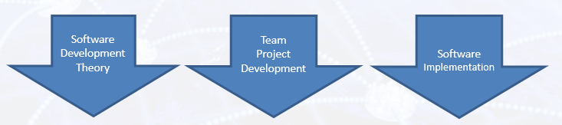

I provide a weekly “Read Me First” file that will list meeting times, videos to view, due dates, and other information.

Educational Approach / Philosophy of Education

I hope to provide a challenging learning experience that build foundational knowledge and provide students with ‘deep learning’. This will be a collaborative endeavor, and requires self-learning students who care about the material. A truly successful course is not just about getting a grade; it should change, enhance or transform your life.

“The value of a college education is not the learning of many facts but the training
of the mind to think." - Thomas Edison

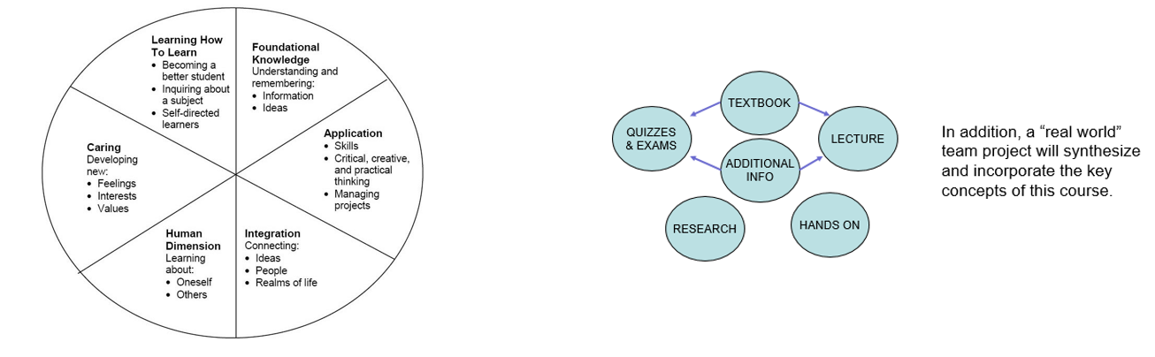

“Today, companies expect not only technical hard skills, but also so-called professional skills [which] include communication, project management, conflict management, diversity management and teamwork.” – Marc-Oliver Pahl

Required Text and Personal Laptop for Lab Exercises

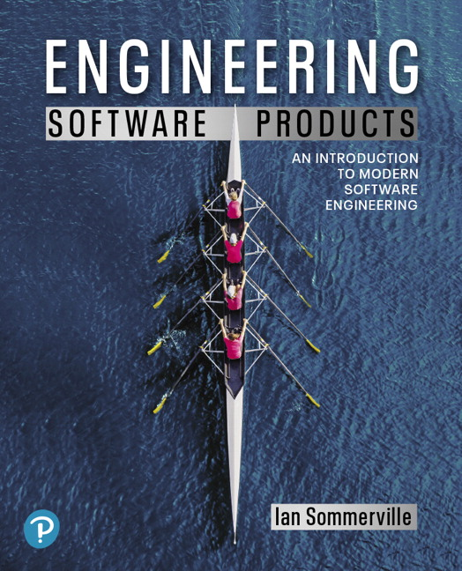  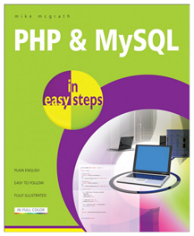 | “PHP & MySQL in Easy Steps” by Mike McGrath  Note: Second edition features SQL version 8!  “Engineering Software Products” by Ian Sommerville  Free software: MAMP Web Server, PHP, MYSQL  Online references: www.w3schools.com  Refer to my website for links to articles, videos, etc.  https://aptokash.github.io/Home/

I expect students to read and master the textbook material. This will help you become self-learners, an important skill for your future careers. I also strongly recommend anyone pursuing a career in software to read “The Pragmatic Programmer” (2nd edition) by D. Thomas and A. Hunt.

Computer Science Department Goals

- Prepare students for employment or graduate study in a technology field.
- Provide students with both theoretical knowledge and skills-based proficiencies in the five core technology competencies: programming, hardware, data communications, data management, and systems/software analysis and design.
- Provide students with fundamental knowledge of business administration and management so that graduates will be able to work effectively within businesses and other organizations.
- Develop interpersonal skills for working effectively on teams.
- Develop effective written and oral communication skills.

Course Objectives

- Implement a comprehensive database and web front end using PHP and My SQL [1,2,3]
- Understand user requirements and reflect requirements in final project. [1,3,4,5]
- Describe and implement cloud stack resources required for the project (servers, storage, networking, and human skills) and likely technical problems. [1,2]
- Describe code sustainability and maintenance principles, including proper code documentation, unit test cases, security penetration testing, and sanitizing all inputs. [1,2]
- Describe and Implement Fundamental Principles used in the project including page redirect, secure sign-on, eye-dropper principle, database search [1,2]
- Develop and present comprehensive software and project documentation. [4,5]

A detailed list of ‘core competencies’ is provided in the iLearn resources, which details, by weekly module, expected acquired knowledge topics and demonstratable skills.

I hope students will: master the material and its relationship to other courses; understand the personal and social aspects of the subject; and want to learn MORE about writing ‘good’ code and developing software projects.

Note: Due to the pandemic we’re often forced to incorporate online instruction and online team-work. While this has some drawbacks, it also prepares students for the modern workforce, which more and more include remote employees and online team projects.

Course Evaluation

Students are assessed through exams, self-assessment quizzes, assignments, presentations and projects. Written projects and presentations will be used to assess their interpersonal, written and oral skills.

10% Weekly Self-Assessment (Open Book) Quizzes
25% Lab and Weekly Assignments
25% Semester Project and Presentations
17% Midterm Exam
18% Final Exam
5% Class Attendance and participation

I generally do NOT accept late submissions, nor do I assign extra credit.

The aggregate grading policy for midterm and final grades will be a slightly modified Marist grading system, and will be displayed in the iLearn gradebook. Please continuously monitor your iLearn grade and contact me for any questions. Do not wait until final weeks to bring up any issues.

 | 94 A | 90 A-
87 B+ | 83 B | 80 B-
77 C+ | 73 C | 70 C-
65 D+ | 60 D

All assignments are to be submitted by the due date specified. Late submissions – if accepted – will have a 20% penalty. NOTE: I generally do not provide extra-credit or make-up assignments.
Make-up opportunities for assignments, assessments, and exams are provided only for verifiable extenuating circumstances cleared through CAAS. Acceptable excuses for late submission of assignments include situations covered in the Student-Athlete Handbook, illness, and serious extenuating circumstances (e.g., death in the family, serious illness).

Class Attendance Policy

Students are expected to attend all classes and to actively participate in classroom activities and discussions. Cell phones/laptops/tablets may only be used for note taking and doing labs. I expect all students to be respectful.

Semester Schedule

Below is the tentative semester schedule. It is a work in progress and will change through the semester. The “READ ME FIRST” file in iLearn will be updated and will reflect the current schedule. I will display it at the start of each class.
A | Week | LECTURE
1 | 8/30 | Introduction, projects, Agile, PHP, HTTP, MySQL, ip addresses, DNS, Ports
2 | 9/6 | Agile, Sprints, Scrums, Pair Programming, User Stories
3 | 9/13 | User stories into Requirements, HTML Navigation
4 | 9/20 | Data Requirements, Databases, Mysql
5 | 9/27 | Architecture, Functional Requirements, SQL Tables
6 | 9/28 | Working with SQL Tables - Data
7 | 10/4 | MIDTERM! PHP!
8 | 10/11 | PHP, Include/Require/ Connect to DB
9 | 10/18 | PHP, Queries, Best Practices
10 | 10/25 | Reliability, PHP controlling progress, strings, arrays, functions
11 | 11/1 | A: Review; B: Creating & Using Forms
12 | 11/8 | Error Checking, Testing, Update & Delete
13 | 11/15 | Session Variables, User Login, Security
14 | 11/22 | More PHP, Documentation
15 | 11/29 | Dev Ops. (Code Review, Peer review)
 |  | Final Project & Final Exam

Submission Guidelines

Assignment, lab and project files must be submitted into ILearn. Documents must follow a standard naming convention and have proper page headers. Refer to the file “Submission Guidelines” in the Ilearn Resources section.

Note: For group/team work, all members must submit in ILearn!

The guidelines file also lists information on using/citing references and the difference between a 90% A and a 100% A.

The “Read Me First File”

As detailed above the course “READ ME FIRST” provides: key to-do’s and dates, the current schedule, core competencies and more.
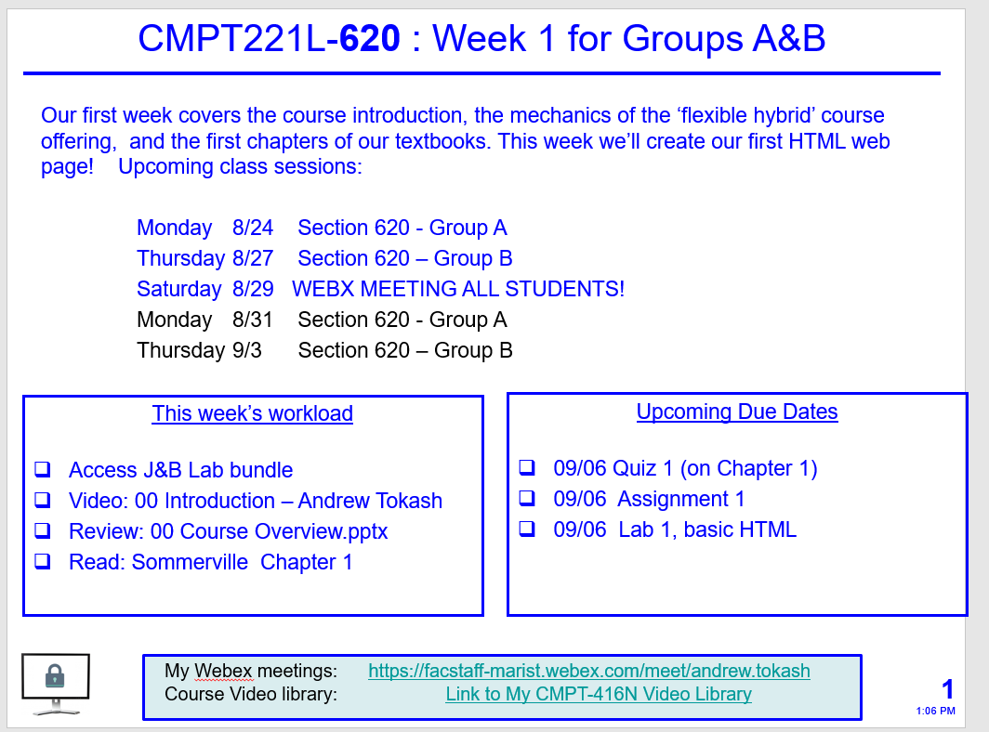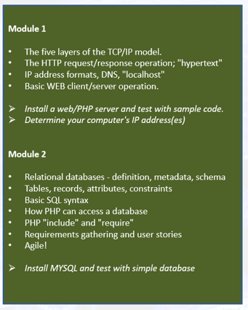

Learning Disabilities

Students have all types of learning disabilities. It is your responsibility to notify the professor in the beginning of the semester in order to make sure you are successful within this course! If you’re unsure whether you have a learning disability, make sure you see Special Services within Donnelly as soon as you suspect your disability.

Academic Honesty

Faculty will uphold and enforce the general policies of this institution on academic honesty and plagiarism. All examinations, assignments, and projects are subject to the standards of academic honesty as described in the Student Handbook and/or other related publications.

Neither plagiarism not cheating will be tolerated. If you are suspected of cheating, you will be asked to explain the work. If you cannot you will be ejected from the course with a failing grade, in addition to any other forms of recourse available to the instructor as specified by the Student Handbook.
You are encouraged to discuss the course material, concepts, and lessons with other students in the class. However, your labs, exams and discussions must be your own work. If you are caught copying or otherwise submitting material that is not solely your work, you will fail the course and a letter will be sent to the department chair.

Please consult the ACM code of ethics. See www.acm.org/constitution/code.html.

Diversity and Inclusion

The college's academic mission is immeasurably enriched by students with diverse experiences. Our finest efforts as intellectual beings heavily rely on the exchange of ideas. Interactions in our classrooms among persons and groups with diverse backgrounds, ideologies, and experiences facilitate these efforts by allowing us all to be more reflective about the varied historical and social contexts in which we work and learn.

In this course, we will challenge each other’s thinking while working collaboratively to ensure that the classroom is a space of safety and bravery. Our classroom offers an environment where individuals of varying opinions, experiences, and backgrounds can freely learn without fear of being silenced.
Aspects of diversity include, but are not limited to, race, ethnicity, color, nationality, sex, gender, gender identity, gender expression, class, sexual orientation, religion, age, ability, and veteran status. Students who would like to be identified in a manner other than what is indicated on the course roster can contact me privately to indicate name, pronoun and any other preferences they may have.

How to Get an “A”

- Attend classes. If something is unclear ASK for a better/different explanation.
- Be an active student. Take notes, listen, speak, ask questions.
Refer to: http://www.dartmouth.edu/~acskills/success/notes.html
- Do a quick review of chapters BEFORE the class to identify confusing sections.
- Read the chapter and review each section’s TEST YOUR UNDERSTANDING questions.
- Do all assignments and submit them on time with proper formatting and citations. Begin assignments early in case you have questions.
- Do not copy assignments from other students, the Internet or any other source.
- Take your time when doing the SELF ASSESSMENTS. Review material BEFORE taking the quiz.
- Study for the exams. Use the Core Competencies as a study guide.
- Work with other students and take advantage of office hours.
- Monitor your grades weekly!
- Use a flashcard app (ex: Quizlet) to utilize flash cards as a study tool.
- Participate fully in team projects!
- Use the Marist Writing Center and the other resources.
- If you have any questions, confusion or issue, address them immediately. Do not wait until the end of the semester to do so.

Changes to This Syllabus

08/15/2021 Original syllabus for fall 2021
08/28/2021 Updated for first day of class
09/01/2021 For group work, all members must submit to ILearn

End of Document

The reference number in brackets [ ] indicates the department goal that is being met with the fulfillment of the objective.

